Images are available in the graphics tab.

Monday

No one ever plans to be in a crash. #BuckleUp every trip—every time—every seat—no matter the distance. #DSWW2015 #PlanAhead
#PlanAhead to wear the right shoes for driving & carry the shoes you want to wear when you get there. #DSWW2015
(Add infographic as photo)
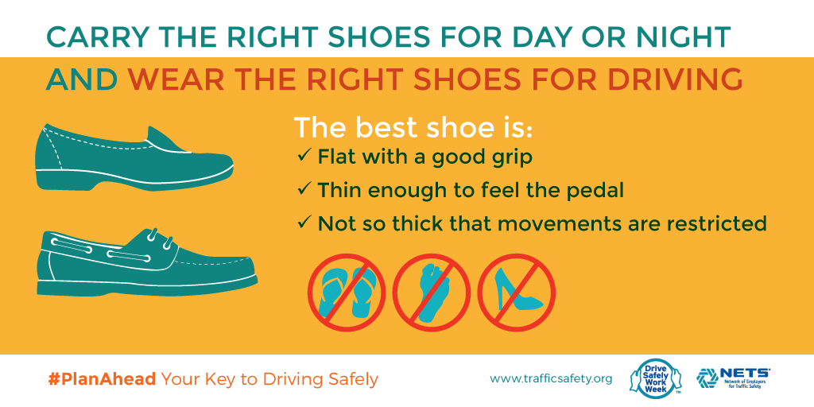

Tuesday
Driving a rental? #PlanAhead and rent a car ‘like a boss.’ #DSWW2015 (Add infographic as photo)

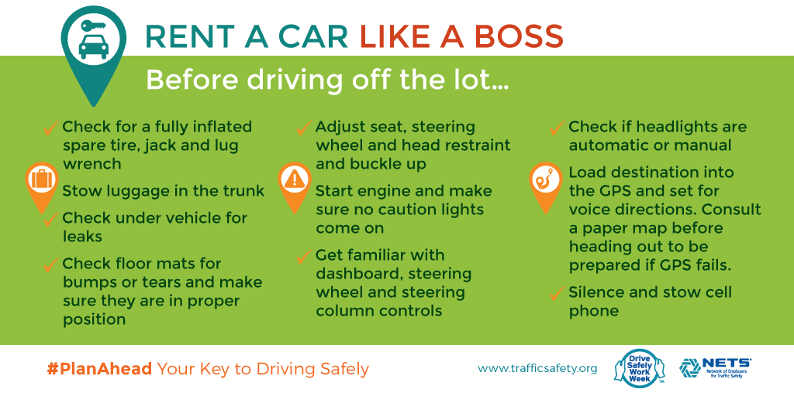
Taking a cab? Don't let safety take a back seat. #BuckleUp & be sure the driver buckles up, too. #PlanAhead #DSWW2015 (Add infographic as photo)
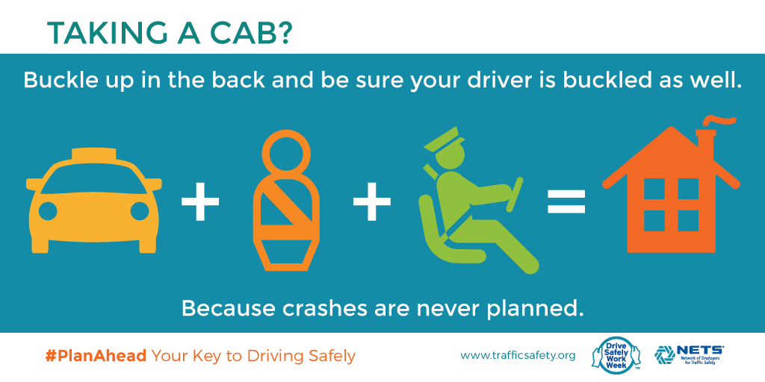

Wednesday

Taking allergy, cold or other meds? Know how they can affect driving so you can #PlanAhead for a clear head: www.roadwiserx.com #DSWW2015

Planning to consume alcohol? #PlanAhead for a designated driver or other safe & sober ride home. #DSWW2015 (Add infographic as photo)
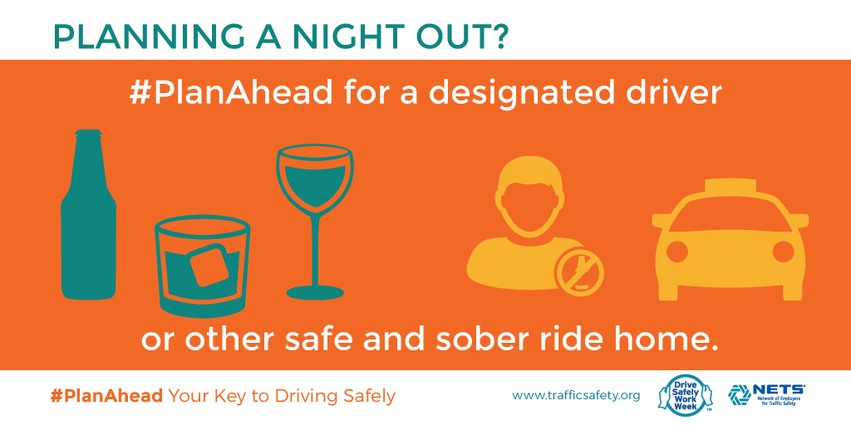

Thursday

90% of a driver’s reaction time depends on vision. When did you last have yours checked? #PlanAhead #DSWW2015 (Add infographic as photo)
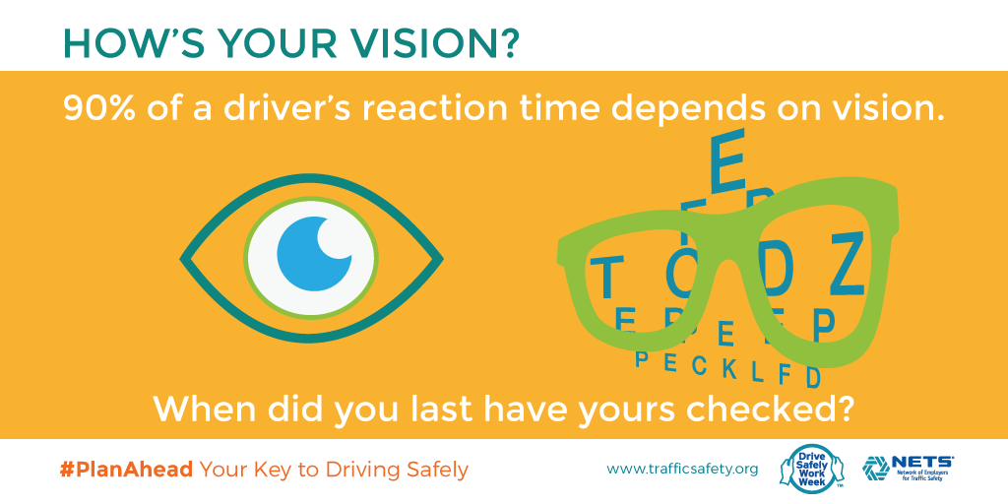
Pack smart snacks to satisfy hunger & help maintain alertness behind the wheel. #PlanAhead #DSWW2015 (Add infographic as photo)
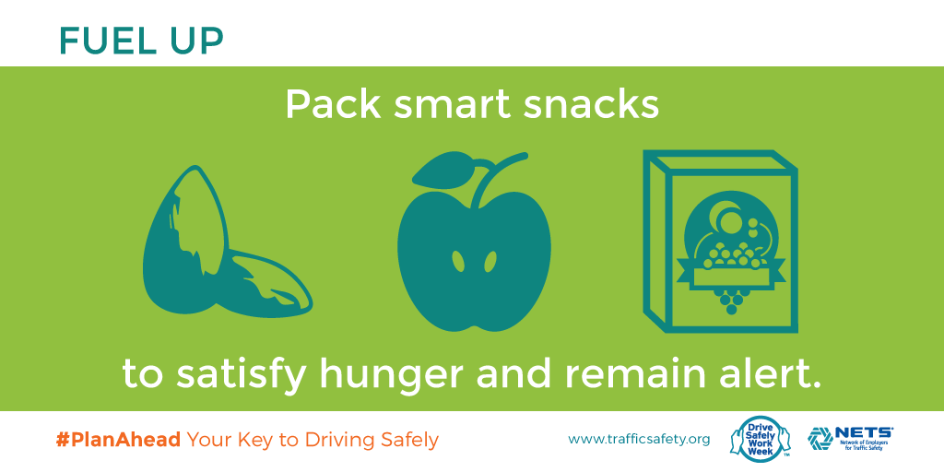

Friday

#PlanAhead to be sure your child is in the right car seat as he/she grows. #DSWW2015
(Add infographic as photo)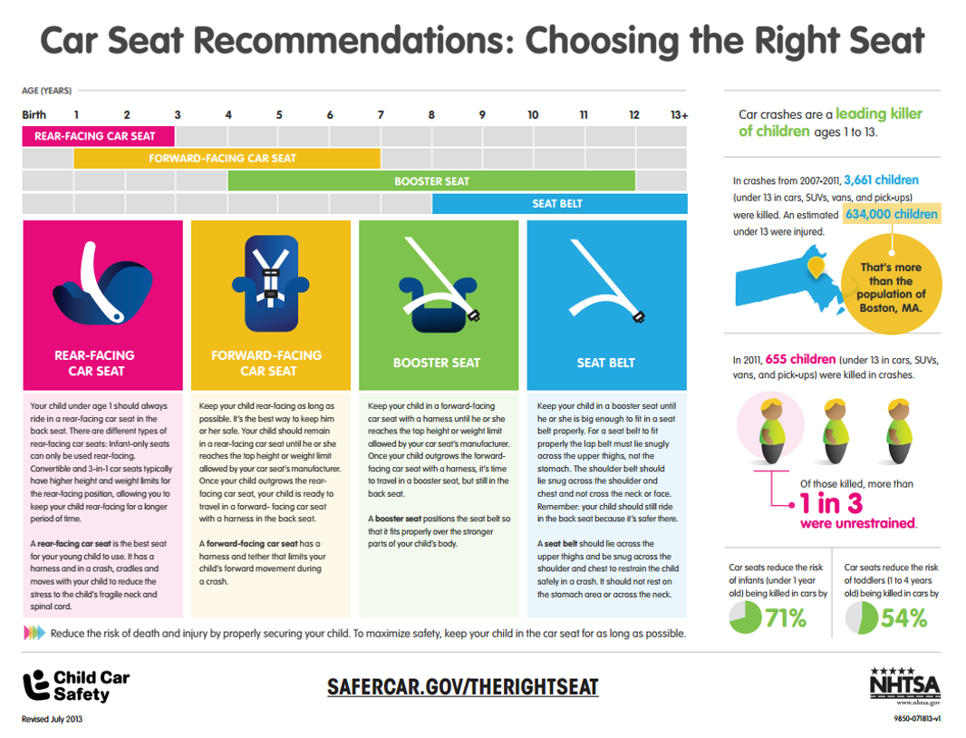

#PlanAhead to take time to practice with your teen driver every chance you get. NETS’ FREE Guide will help! #DSWW2015 (Add image as photo)

