Monday

It’s Drive Safely Work Week—#PlanAhead to put your best foot forward for driving
Watch: Sheldon “flip flop fatality” https://www.youtube.com/watch?v=ZMEueCOMSH8
#PlanAhead to carry the right shoes for the day/night and wear the right shoes for driving!
- Avoid barefoot driving. If you need to stop quickly, a bare foot may not provide enough braking force—and heavy force can lead to injury.
- Flip flops can easily slide off your feet and off the pedals—decreasing your reaction time.
- High heels can get stuck in floor mats and force feet into unsafe angles that impact reaction time and braking force.
- Shoes with very smooth soles can slip off gas and brake pedals—impacting driving safety.
The best shoes for driving have non-slip soles and allow the foot to feel the pressure needed by the pedals to achieve the desired braking or acceleration. #PlanAhead. You can always change shoes once you arrive at your destination.
#PlanAhead – Your key to driving safely.

[Use this graphic in addition to or instead of the text above.]
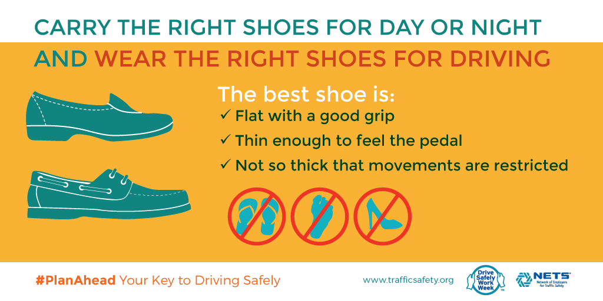

Tuesday

Rent a Car Like a Boss
Before driving off the lot:
- Check for a fully inflated spare tire, jack and lug wrench
- Stow luggage in the trunk
- Check under the vehicle for leaks
- Check floor mats for bumps or tears and make sure they are in proper position
- Adjust seat, steering wheel and head restraint and buckle up
- Start engine and make sure no caution lights come on
- Get familiar with dashboard, steering wheel and steering column controls
- Check if headlights are automatic or manual
- Load destination into the GPS and set for voice directions. Consult a paper map before heading out to be prepared in case GPS fails
- Silence and stow cell phone
#PlanAhead – Your key to driving safely.
[Use this graphic in addition to or instead of the text above.]
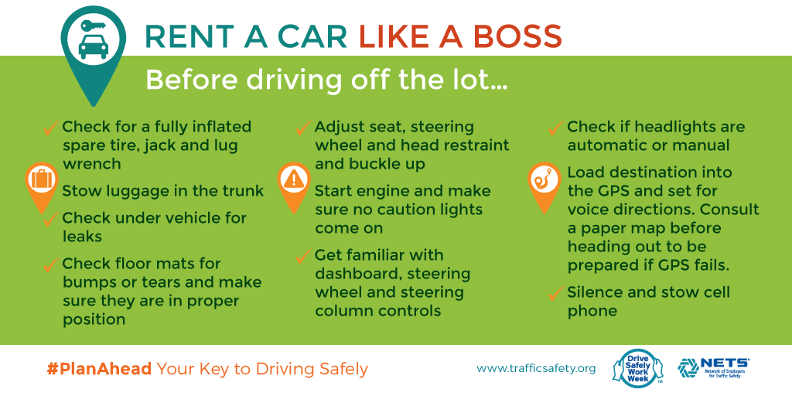
Wednesday

Not getting the sleep you’re dreaming of? It may be time to bounce your mattress.
While common belief is that you need to replace your mattress every 7–10 years, there may be signs even sooner that you’re lying in the wrong bed. In addition to looking for indications of wear and tear, keep in mind that our bodies change over time and the need for comfort and good support only increases with age, meaning even a mattress that is still “good” may now be bad for you.
Are you:
- Waking up with aches and pains? This indicates your mattress is not giving the support you need.
- Sleeping better in hotels than at home? There’s a good chance it’s because the bed is more comfortable.
- Sneezing more than snoozing? Your mattress may be harboring allergens that can be preventing restful sleep.
Take a minute to assess your sleep sanctuary and determine if it’s time to make some changes. Consistent, restful sleep is priceless. A mattress that does its job well is a great investment.
#PlanAhead—Your key to driving safely.
Thursday

Working in a quick workout while at work
The physical aspect of driving requires flexibility and strength. Being limber helps your entire body to move more freely, allowing you to observe the road from all angles. It will also increase comfort on long drives, and can assist in warding off fatigue, helping to improve reaction time and allowing you to be better focused. Hours spent sitting, whether at your desk or on the road, can be tough on your body. But there are simple exercises you can do right at your desk or during a rest stop to help you improve your body’s flexibility and strength. Take every opportunity to get yourself moving, even if just for a few minutes at several intervals throughout the day. Just be sure to check with a doctor before starting any new exercise regimen.
Here are a few ideas to get you started:
- Park in the outer areas of parking lots to get in some extra steps
- Take the stairs instead of the elevator
- Stand up when you talk on the phone or attend a meeting
- Take a brisk 10-minute walk during a break, a rest stop or at lunchtime
Do some simple exercises at your desk. This link from the Washington Post has some great moves that include visuals: www.washingtonpost.com/graphics/health/workout-at-work/
#PlanAhead – Your key to driving safely.
Friday

Whether you have toddlers, teens, aging parents/grandparents or any combination thereof, opportunities abound to #PlanAhead when it comes to keeping your family safe on the road. As we wrap up Drive Safely Work Week, here are some great tools and resources to help you keep your family safe on the road not just this week but in the years to come.
#PlanAhead to ensure kids are in the right car seat as they grow: http://www.safercar.gov/parents/CarSeats/Car-Seat-Safety.htm
#PlanAhead to make time to practice with your teen driver—Use the practice curriculum in the FREE e-Novice Driver’s Road Map developed by NETS as your guide: http://trafficsafety.org/e-novice-drivers-road-map-available
#PlanAhead to help senior relatives make plans for driving Retirement: http://www.nhtsa.gov/Driving+Safety/Older+Drivers
#PlanAhead to ensure your vehicle is road ready, you’ve planned your route and planned for the unexpected when it comes to family vacations: http://www.safercar.gov/SummerDrivingTips
#PlanAhead – Your Key to Driving Safely.

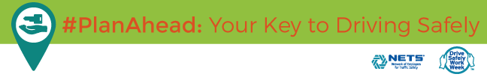
[Footer may be downloaded in the Graphics tab.]

